* 1. Which of these are endogenous calcium buffers?
  + parvalbumin
  + BAPTA
  + Calbinden
  + FITC
* 2. Circle the routes of Ca2+ entry from outside the cell
  + Ca2+ ATPase
  + NMDA receptors
  + G-protein coupled receptors (GPCRs)
  + Voltage-gated calcium channels (VGCCs)
  + Mitochondrial calcium uniporter

3. Identify three cellular calcium sinks

Endosomes

Endoplasmic Reticulum (ER)

Mitochondria

Lipid membranes

Parvalbumin

BAPTA

4. Circle the appropriate sign (<,>,=) for comparison of the binding ratios (kappa). Use the values provided in the table following.

*(Hint: remember that K=[B]/Kd)*

200 μM Fluo-4 < > = 10 μM Fura 2

200 μM Oregon Green 488 Bapta 6F < > = 10 μM Fura 2

10 μM Oregon Green 488 Bapta 2 < > = 10 μM Fura 2

|  |  |  |  |  |  |  |  |  |  |  |  |  |  |  |  |  |  |  |  |  |  |  |  |  |  |  |  |
| --- | --- | --- | --- | --- | --- | --- | --- | --- | --- | --- | --- | --- | --- | --- | --- | --- | --- | --- | --- | --- | --- | --- | --- | --- | --- | --- | --- |
| |  |  | | --- | --- | | **Calcium indicator** | **Kd, nM** | | Fluo 3 | 390 | | Fluo 4 | 340 | | Fluo 5F | 2300 | |  |  | | Fura 1 | 107 | | Fura 2 | 135 | | Fura 3 | 140 | |  |  | | Oregon Green 488 Bapta 1 | 170 | | Oregon Green 488 Bapta 2 | 580 | | Oregon Green 488 Bapta 6F | 3000 | | Oregon Green 488 Bapta 5N | 20000 | |  |

5. You’ve identified a new cell in the brain and want to characterize its calcium dynamics. You load the cells with 10 μM Fura 2, stimulate an AP and see the following response:

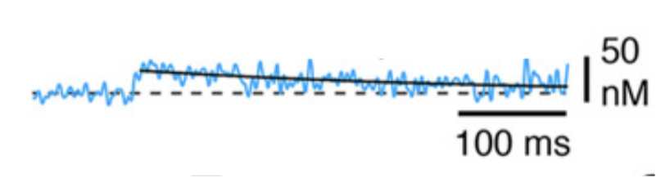

This is a somewhat flattened response from what you expected, and the peak calcium concentration seems really low. Is there another indicator combination from #4 that might be better for this cell?

6. Which of the following is something to consider when trying to design an experiment using a GECI? (hint – there may be more than one answer)

* Dynamic range of the sensor
* Promoter strength & timing
* Microscope capabilities
* Membrane permeabilization